25.78: a) We need to heat the water in 6 minutes, so the heat and power required are:
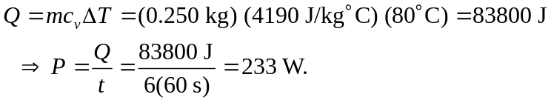
But 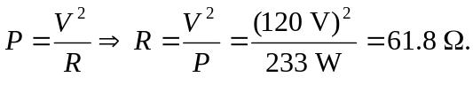
b) 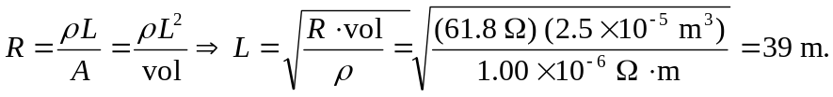
Now the radius of the wire can be calculated from the volume:
